Background Information: ___

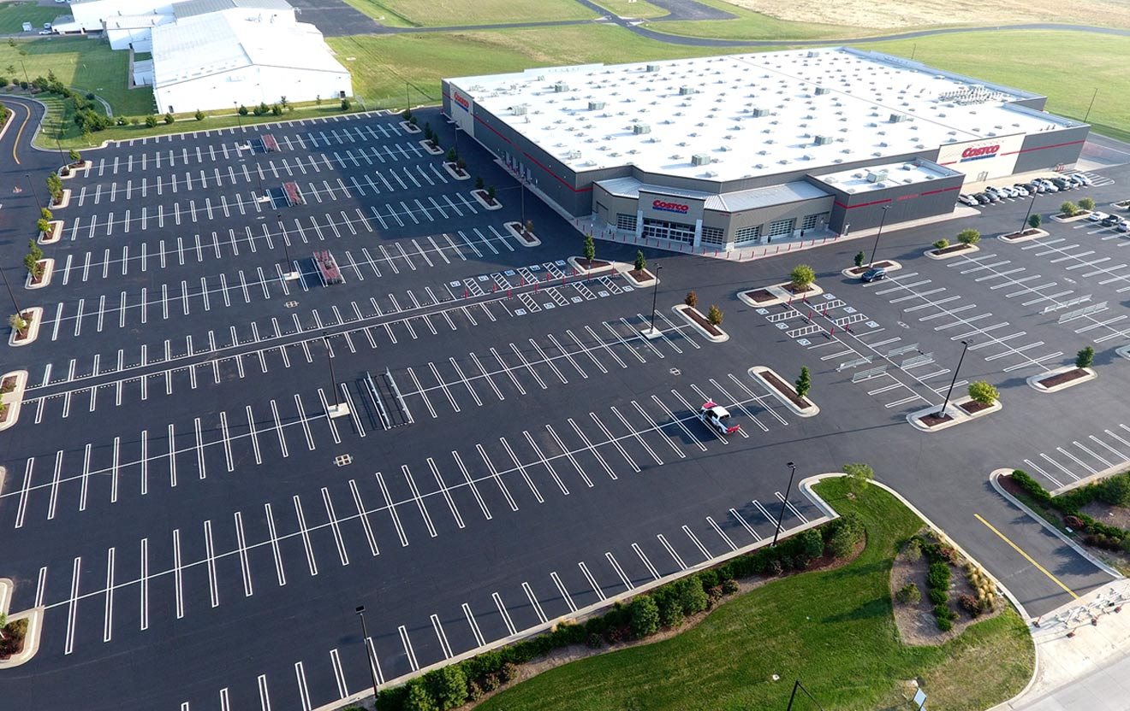

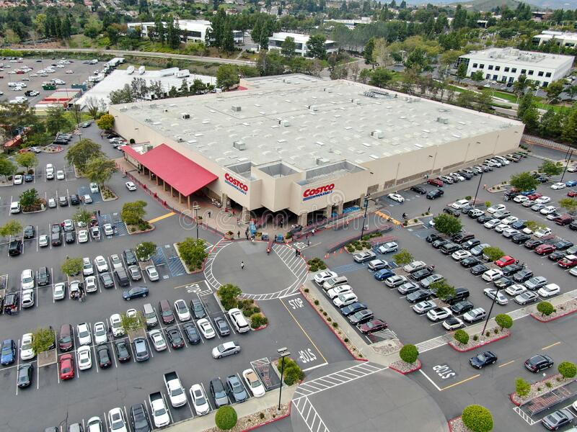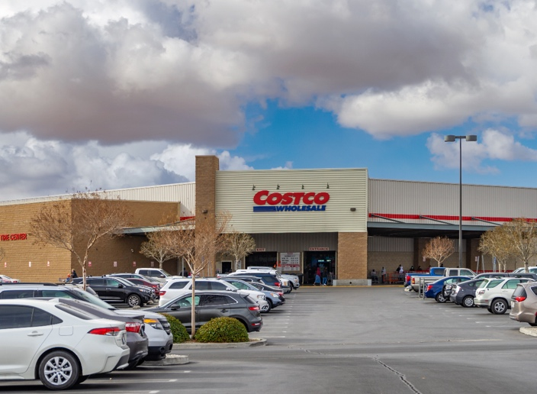

Roles

We delegated each member with the following tasks to push, pull, and fork these categories into GitHub:

1. Jonalyn Davis à Why we came up with this idea?
2. Chan Saechao à What is the design and layout of the application?
3. Sharmaine Estrellas à How does it work?
4. Aeysha Akkad à How do we implement it?

**Why we came up with this idea?**

An organized parking area will eliminate the hassle of looking for a parking space. And this parking app will help customers in having visual idea of where to park, stop customers from getting irritated with each other fighting for a parking space and benefits the company and customers by having organized parking.

What is the design and layout of the application?

Design – Costco Parking Digital Sign

We wanted to create a sign that would be eco-friendly so we came up with the idea to make it run on a solar panel. Initially it would be expensive but in the long run it’ll be worth it as people are able to benefit from it.

The design would be simple such as a green car that represents an open parking space while a red car would represent an occupied space. For each section there will be a solar panel bank that would generate power throughout the day. Once the store is closed the power bank will have a timed off mechanism to conserve the remaining energy.

How does it work?

* It will be accessible on Android and iOS mobile devices
* Opening the mobile app, you will be able to view available parking spot locations two ways:
  + In a map view (red spots = unavailable; green spots = available)
  + List view that will display available and unavailable spots
* Before parking into the available spot, you will be able to reserve it to give you time to find it and park there (time is limited to reserve it and how long you can park it there for)
* Each parking lot row with be labeled alphabetically and the lot itself will be numerical.
* Once parked you will scan QR code sign that is in front of parking spot to confirm spot is unavailable and confirm reservation
* There will also be a sensor in the middle of the parking spot that will sense the car is there too

How do we implement it?

It is not easy to implement this idea, but we can do it by creating digital signage for businesses. We will use it to get your message to the right people at the right time.

I will provide some links that will be useful in creating this idea

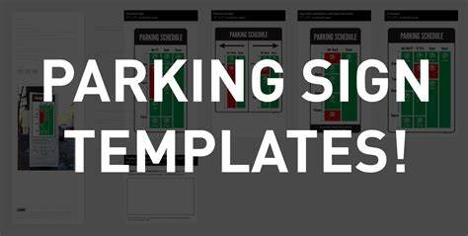

[To Park or Not to Park — I’ve created downloadable parking sign templates...](http://toparkornottopark.com/post/110084117460/ive-created-downloadable-parking-sign-templates) by Unknown Author is licensed under [CC BY-SA-NC](https://creativecommons.org/licenses/by-nc-sa/3.0/)

[Digital Parking Signs | Outdoor Parking Signs | Digital Carpark](https://www.digitalparkingsigns.com/)

[Costco Garage (Impark Lot #28) - Parking Garage](https://www.parkopedia.com/parking/garage/costco_garage_impark_lot_28/94103/san_francisco/)